User Manual: Purchase Proposal Portal

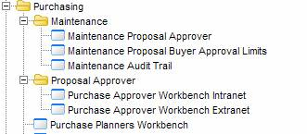

- Maintenance

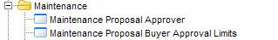

  - Maintenance Proposal Approver
This screen displays all the proposal approvers with their respective Level, PPV Amount and Line Amount. Also the order status that each approver is allowed to approve.
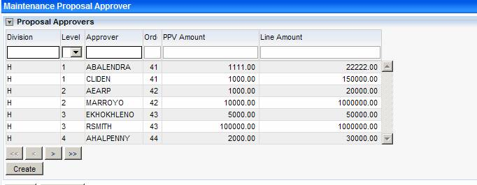

- Create
Right click on the browse segment and take Create or simply click on the Create button.
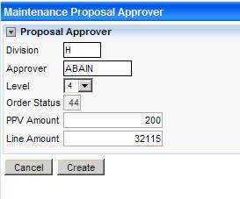
Enter the Approver (or F4), select the Level (Level 1 ➔ Order Status = 41; Level 2 ➔ Order Status = 42 and so on) and enter the PPV and Line amount
Remember that creating an approver mean inserting a record into the table ZAPPROVE

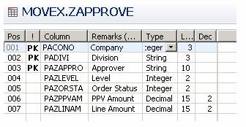

- Update, Delete and View
Right click on the browse segment and take Update, Delete or View.

  - Maintenance Proposal Buyer Approval Limits
This view displays all the buyers with their respective approval limits.
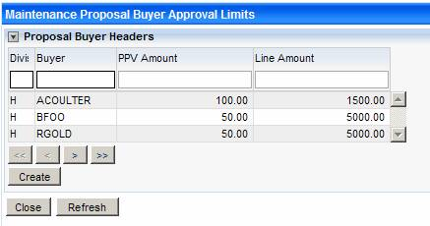

- Create
Right click on the browse segment and take Create or simply click on the Create button.
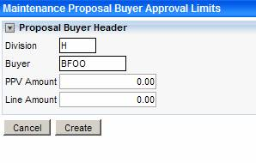
Enter the Division (or F4), Buyer (or F4) , the PPV and Line Amount
Remember that creating an approver mean inserting a record into the table ZBUYERHE

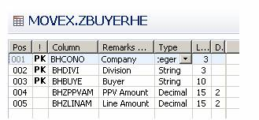

- Update, Delete and View
Right click on the browse segment and take Update, Delete or View.

- Adding Approval Line Limits
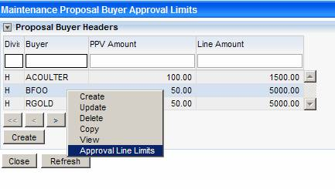

Right click on the view and take Approval Line Limits
This screen displays all the approver attach for a specific Buyer.
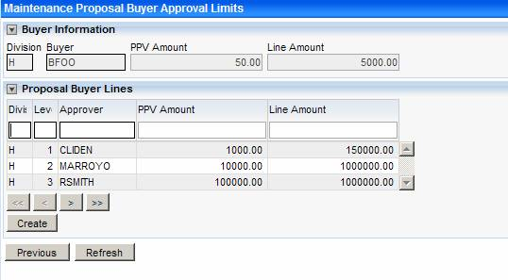

To attach a new approver, click on Create Button
Then, enter the Level you want to look up for
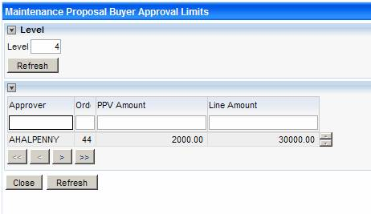
After that, click on the desire approver.
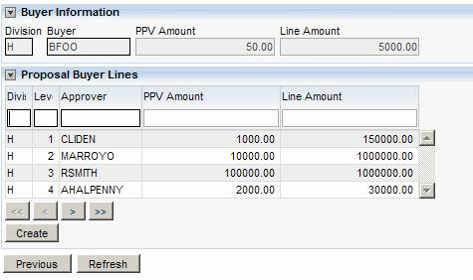

- Proposal Approver
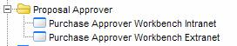

There are 2 links on the menu:
- Purchase Approver Workbench Intranet: will be used by Startronic’s Staff
- Purchase Approver Workbench Extranet: will be used by people out site of Startronic Intranet

2.1 Purchase Approver Workbench Intranet

On this screen, click the Approver from the “select an approver” segment
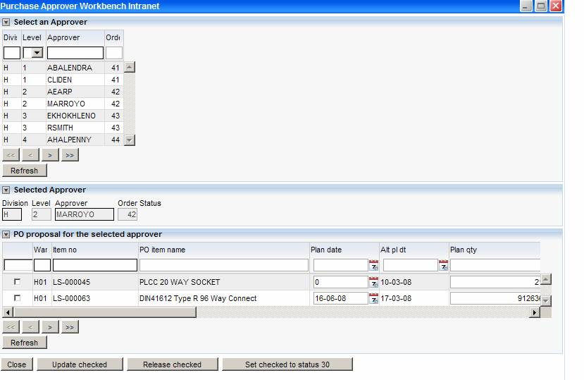
Then, check the PO proposal you want to Update, Release or Set its status to 30

2.2 Purchase Approver Workbench Extranet

This screen displays all the PO Proposal assigned to the current logon user
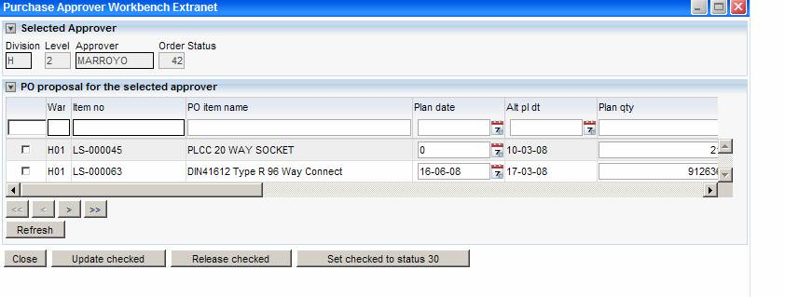
Then, check the PO proposal you want to Update, Release or Set its status to 30

Update
To delete and update, right click and take “Update” or “Delete”
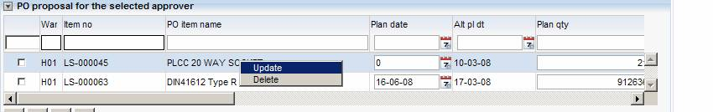

Then you can modify the following input fields
